**Summer Camp Report –May 2022**

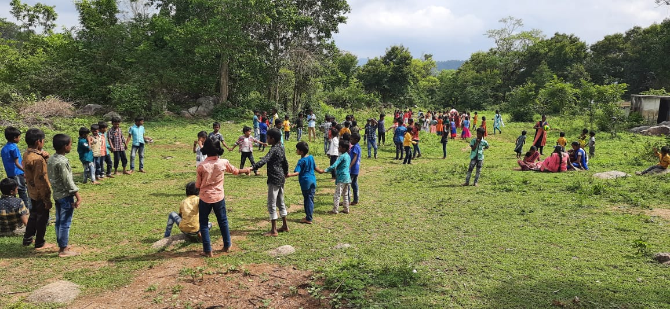

**Dates: 16th to 21 May 2022**

|  |  |  |  |  |
| --- | --- | --- | --- | --- |
|  | Zone | Camp site | Total students enrolled in night school | Total enrolled for camp |
| 1 | Palamarathur | Kalyanamandhai forest school | 180 | 180 |
| 2 | Koiloor | Koiloor forest school | 210 | 187 |
| 3 | Athipet | Don Bosco, JMR | 249 | 242 |
| 4 | Jammunamarathur | Don Bosco, JMR | 179 | 159 |
| 5 | Veerapanoor | Veerapanoor Forest school | 182 | 168 |
| 6 | Nammiyampet | Koilandur Residential school | 226 | 137 |
|  | 6 zones | 6 sites | 1256 | 1073 |

**Training Program for Night school teacher and camp staff:** We held two training programs for all the staff involved in running the camps. The topics covered were child safety, preventing unintentional injuries including drowning, falls and bites, heat exhaustion and hydration, camp cleanliness, food safety and games for children. At the end of the training program the teacher collected 2 T-shirts for each child with the CMC and Don Bosco emblem on it.

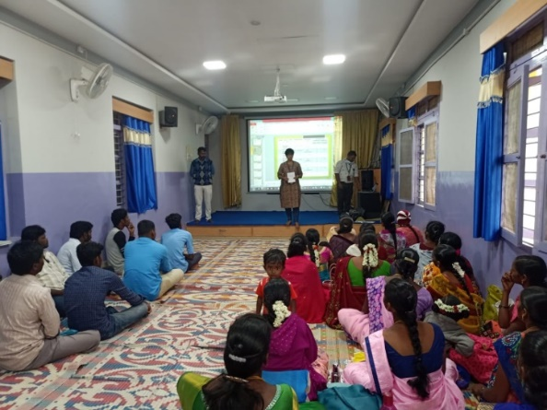

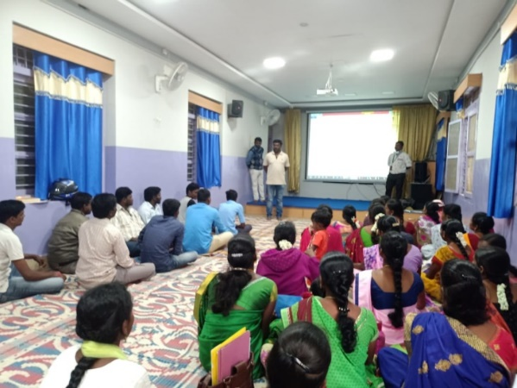

The Community Health Department conducts summer camps for the children enrolled in the Evening study centers in Jawadhi hills every year. This activity is in collaboration with the Don Bosco Tribal Development center in Jawadhi hills. We could not hold camps for the last two years due to the pandemic, and this year’s camp was awaited with much excitement by the children.

This year the camps were from the 16th to 21st of May 2022. 1073 children enrolled for the camps. The camps were held in 6 different locations simultaneously. The centers where they were held are: Jammunamarathur -2 zones, Koilandur, Veerapanoor, Koiloor, and Kalyanamandai. Every day the children were engaged in different activities by several teams of staff from CMC and from Don Bosco, and from trainers from other places in Tamil Nadu. The camp started at 9 :00 am and finished at 3:30pm every day. The children were given refreshments mid-morning and at tea time in the evening, and lunch every day. This year, we anticipated a heat wave, and trained our night school teachers on heat exhaustion and heat stroke, but for the first 4 days of the camp it rained. In each camp, the children worked in teams, with themes, scores and the best team won a prize at the end of the camp. Scoring was on punctuality, discipline, performance during competitions and participation.

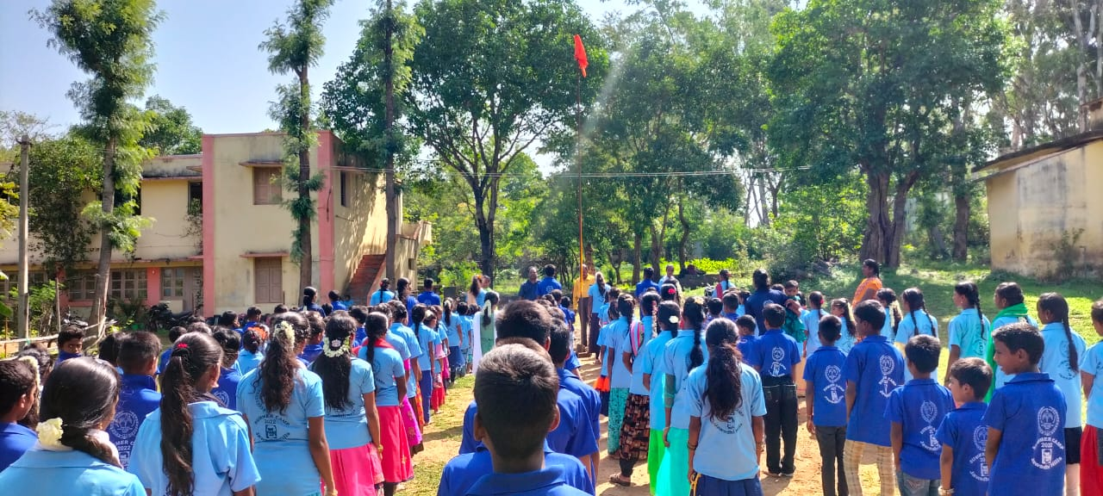

**Activities:**

1. 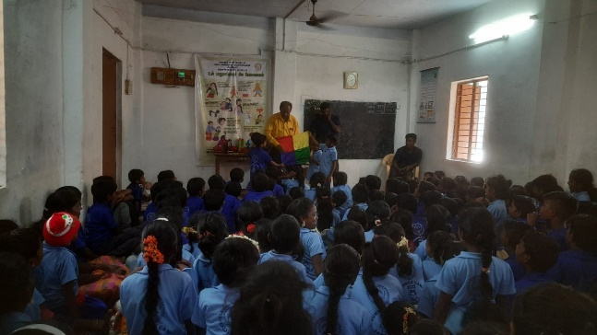**Magic show:**

Each center had a magic show for half a day. We had a magician from Chennai, who comes for all our camps, and he taught the children values using magic as a teaching medium. At the end of the program the magician taught them a few tricks also, and this was the highlight of the day for the children.

1. **Crafts:** This the children learnt clay modelling and paper craft. They learnt the importance of recycling and reducing waste.

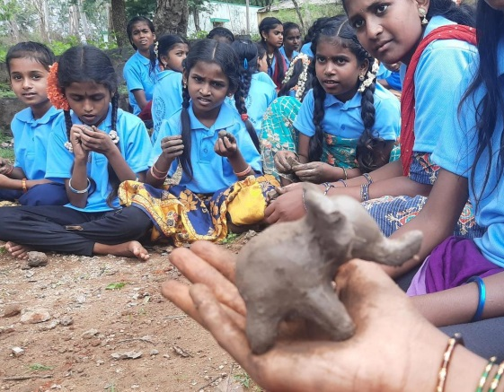

1. 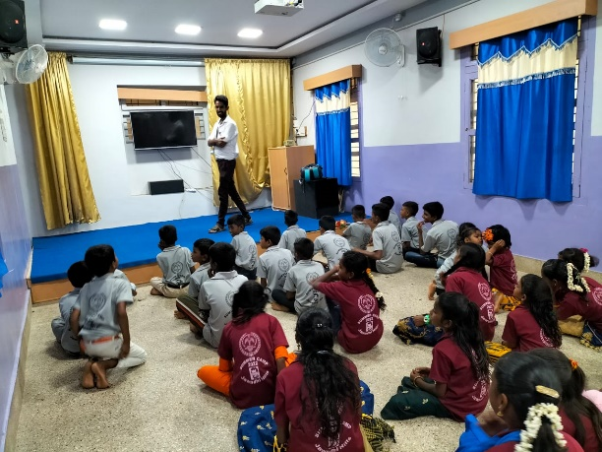**Superstitions- Good, Harmless and Harmful:**  This session is about increasing health seeking behavior among the people. Our social worker Mr. Vivian spoke to the children about superstitions and common practices in the hills. He elaborated the ones that are good and can be followed, such as special nutrition for children and women after delivery, harmless superstitions such as tying a blessed thread around the wrist or ankle to ward off evil spirits, and harmful practices such as exorcisms for seizure disorder which should be stopped.
2. 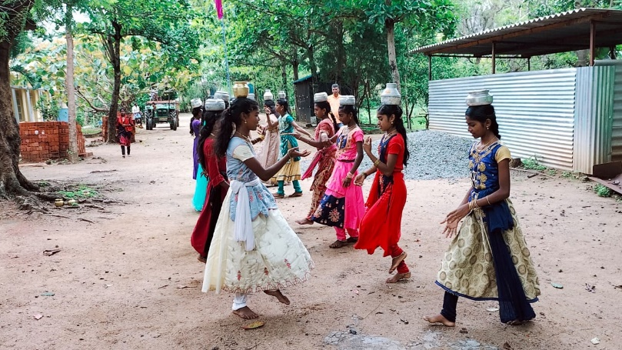**Folk arts:** A folk arts teacher from Chennai taught the children various forms of dance such as Oilattam, gummiattam, kollatam, and karagattam. This is the same group who came in the previous years and continued the teaching from previous years also. The children learnt different types of Tamil dance forms and songs.

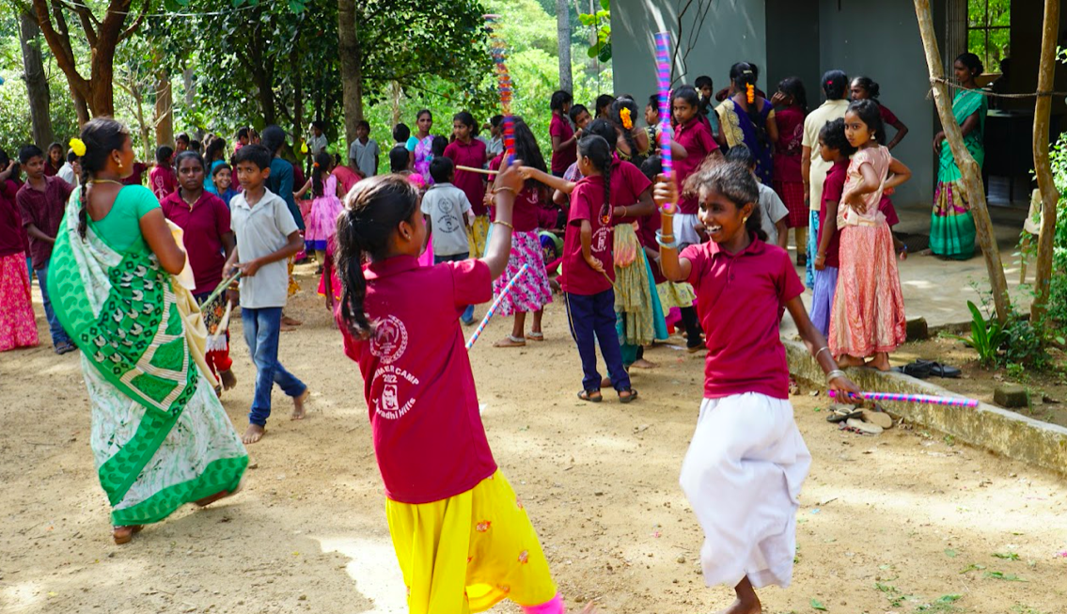

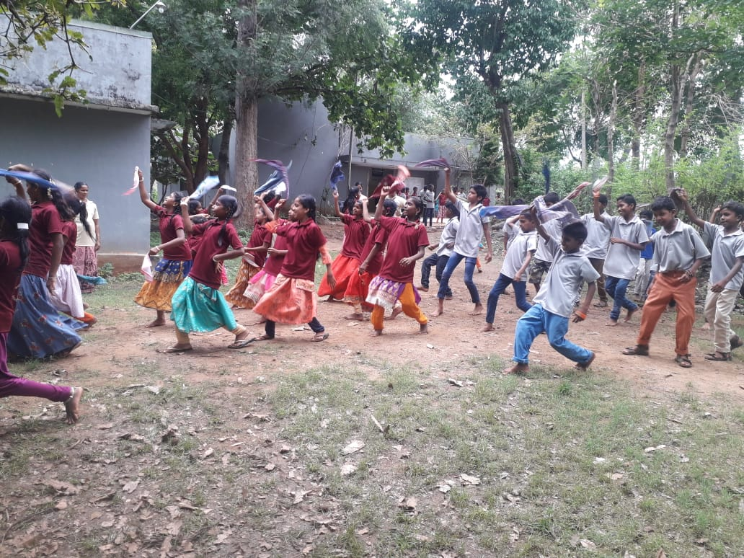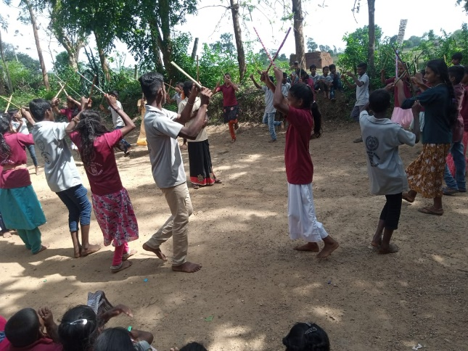

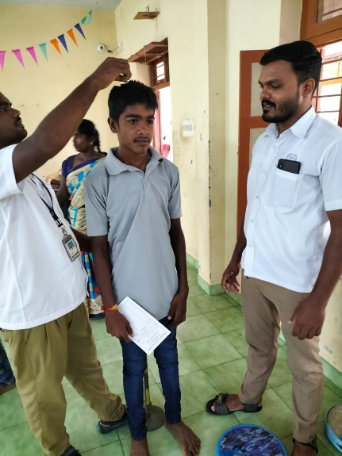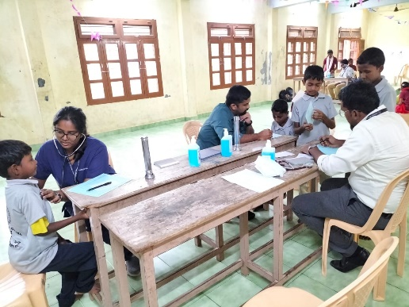**Medical**

1. **Medical check-up:** All children had a medical checkup. Height and weight were recorded to assess nutrition. They were screened for refractive errors and vitamin deficiencies, common skin diseases and systemic illnesses. Children who need further medical attention were referred to CMC and their treatment will be coordinated by CHAD. There were 23 children with medical conditions needing further evaluation and 11 children with refractive errors needing further attention. All other minor illnesses were treated in the camps itself. We will analyze the height and weight to determine nutritional status and follow up children who need attention

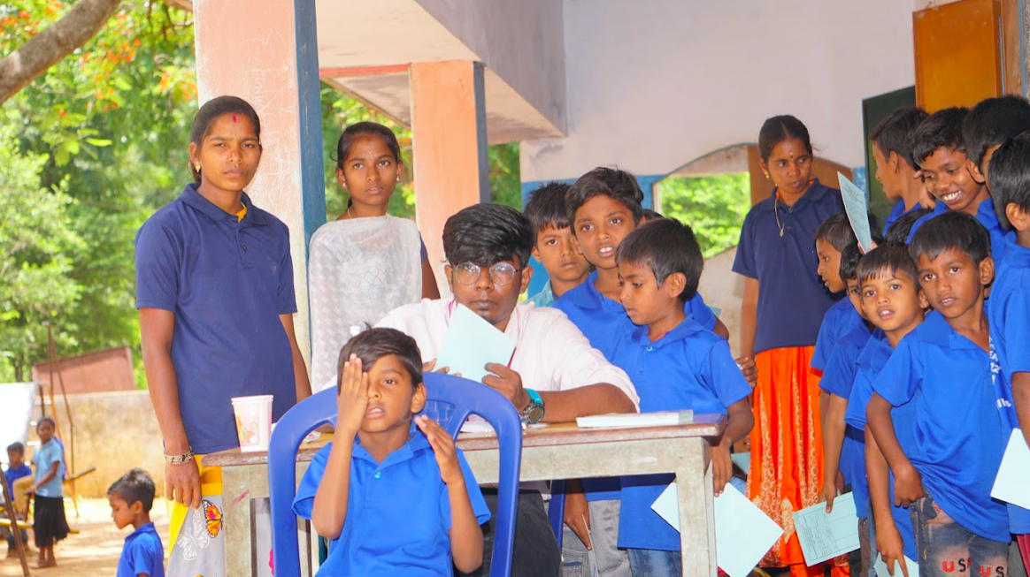

1. **Farm animals:** The government Veterinary doctor, Dr. Varatharaj, who also looks after all the Model village project animals,taught the children about looking after household and farm animals. He spoke about nutrition, immunization and early medical attention for animals.
2. 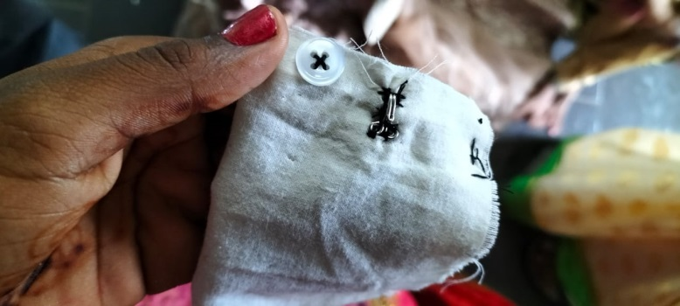**Sewing:** This year, as a skill we chose sewing for two reasons. It is a useful skill for children to learn and to break gender stereotypes. The children learnt how to sew on buttons, make a button hole, sew a hook, hemming and darning.
3. **Kitchen garden:** The children learnt how to grow common vegetables and greens and to develop a kitchen garden. They were given seeds and will be followed up.
4. **Forrest conservation:** The children had sessions on the importance of forest conservation, planting fruit trees and useful plants and sustainable agriculture. They learnt of the harms of destroying forests and the damage to the environment.
5. 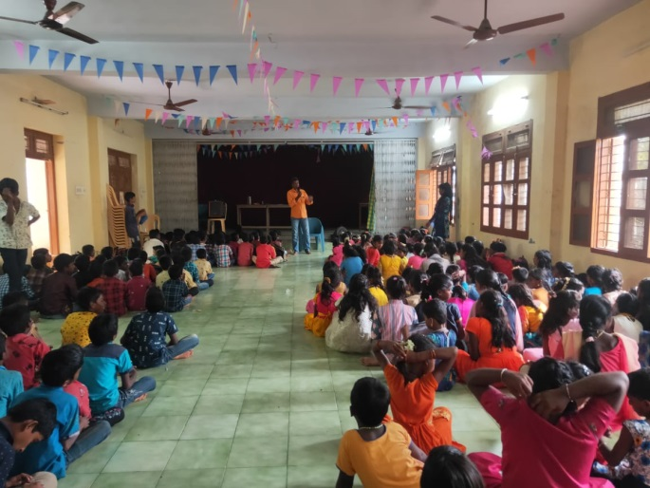**Substance abuse:** Substance abuse continues to be a problem in Jawadhi with younger and younger people engaging substance abuse, mainly alcohol consumption. It is a significant problem here, with data from CHAD showing the age of initiation into alcohol is as young as 8 yrs. The children had a session on the harms of alcohol use. This was mainly in the form of songs and drama. A health educator from the tribes, who was previously trained by CHAD conducted the sessions, and this led to several children asking if they could bring their family members to the substance abuse clinic run by CHAD.
6. **First aid**

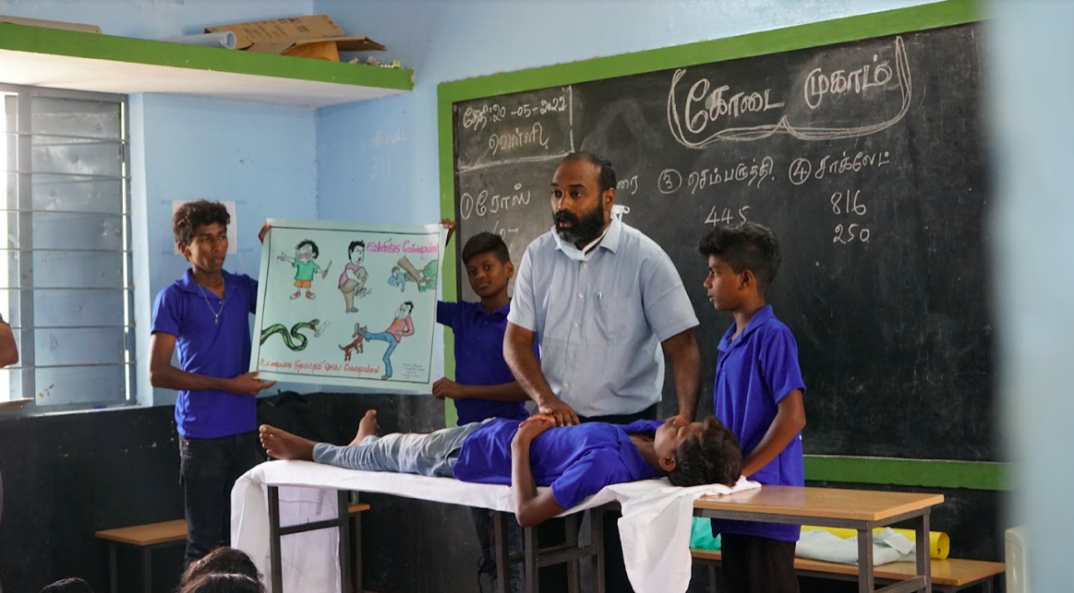

Mr. Sam from CHAD taught the children first aid, for common conditions such as injuries, bites, fractures, nose bleeds etc. the children got chances to demonstrate making a sling, log-rolling a patient etc.

**Refreshments Menu:**

|  |  |  |  |
| --- | --- | --- | --- |
|  | Morning snack | Lunch | Evening snack |
| Day 1 | Mango juice, butter biscuits | Tomato rice, potato fry, egg curry, banana | Chick peas |
| Day 2 | Grape juice, ragi biscuits | Tamarind rice, carrot poriyal, chicken curry, Mosambi | Green Peas |
| Day 3 | Orange juice, salt biscuits | White rice, sambar, cabbage poriyal, egg curry, watermelon | Moong dhal |
| Day 4 | Pineapple juice, Marie biscuits | Vegetable biriyani, beetroot poriyal, chicken curry, Mango | Groundnuts boiled |
| Day 5 | Orange juice, cream bun | Lemon rice, potato fry, egg curry, watermelon | Chick peas |
| Day 6 | Mango juice, Makhan beda sweet | White rice chicken curry, banana | *Camp close* |

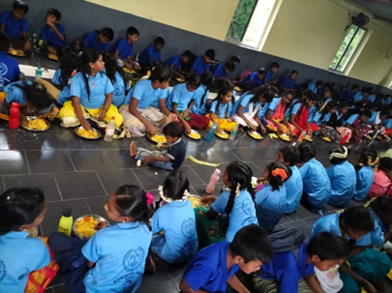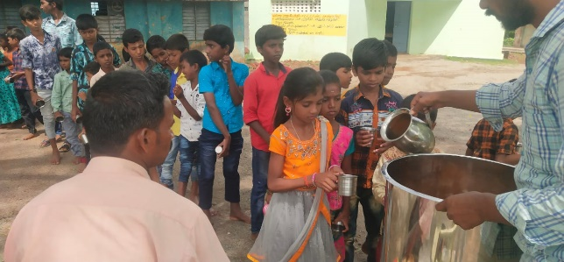

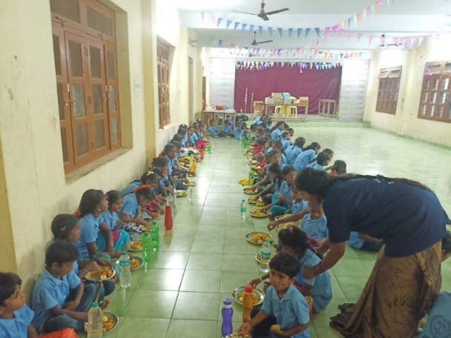

**Medical Camp referrals**: 23 general complaints including children with murmurs. , 11 opthalmology complaints, mainly refractive errors. These children have been referred to CMC and will be followed till treatment is complete.

**Positive points:** This camp helped us to network with the local schools, the forest department, the local veterinary services and the local PHC also it was a great way to form relationships with the people of the 50 villages were the night schools are situated. It helped us strengthen our network with the Don Bosco team.

**Issues:** We had to move the camp which was to be in Athipet to Jamunamarathur as in the last minute we found out that the school we wanted to use did not have a structural safety certificate. It was difficult to have 2 zones in the same location.

In the Veerapanur Zone on the first day of the camp we found there was no water. We had to buy water for the subsequent days.

On the fifth day of the camp one child, a 10 year old boy, fell down and sustained a supracondylar fracture of the right elbow. He was treated in CMC and is on a POP cast now.

This camp was possible because of enthusiastic participation from CMC and from Don Bosco Tribal Development Society. From CMC, the Child Health Department deputed 6 doctors to attend the camps. From CHAD two consultants, an intern, two social workers, an accountant, nurses and our occupation therapist attended every day. Optometrists were also involved in the camps every day.

The summer camps and the activities of the evening study centers are supported through donations from the FOV’s, mainly Germany. The other FOV’s that support the night school activities including the summer camps are Sweden, the United States and Australia. The Community Health department thanks the FOVs for the support and prayers for this activity.